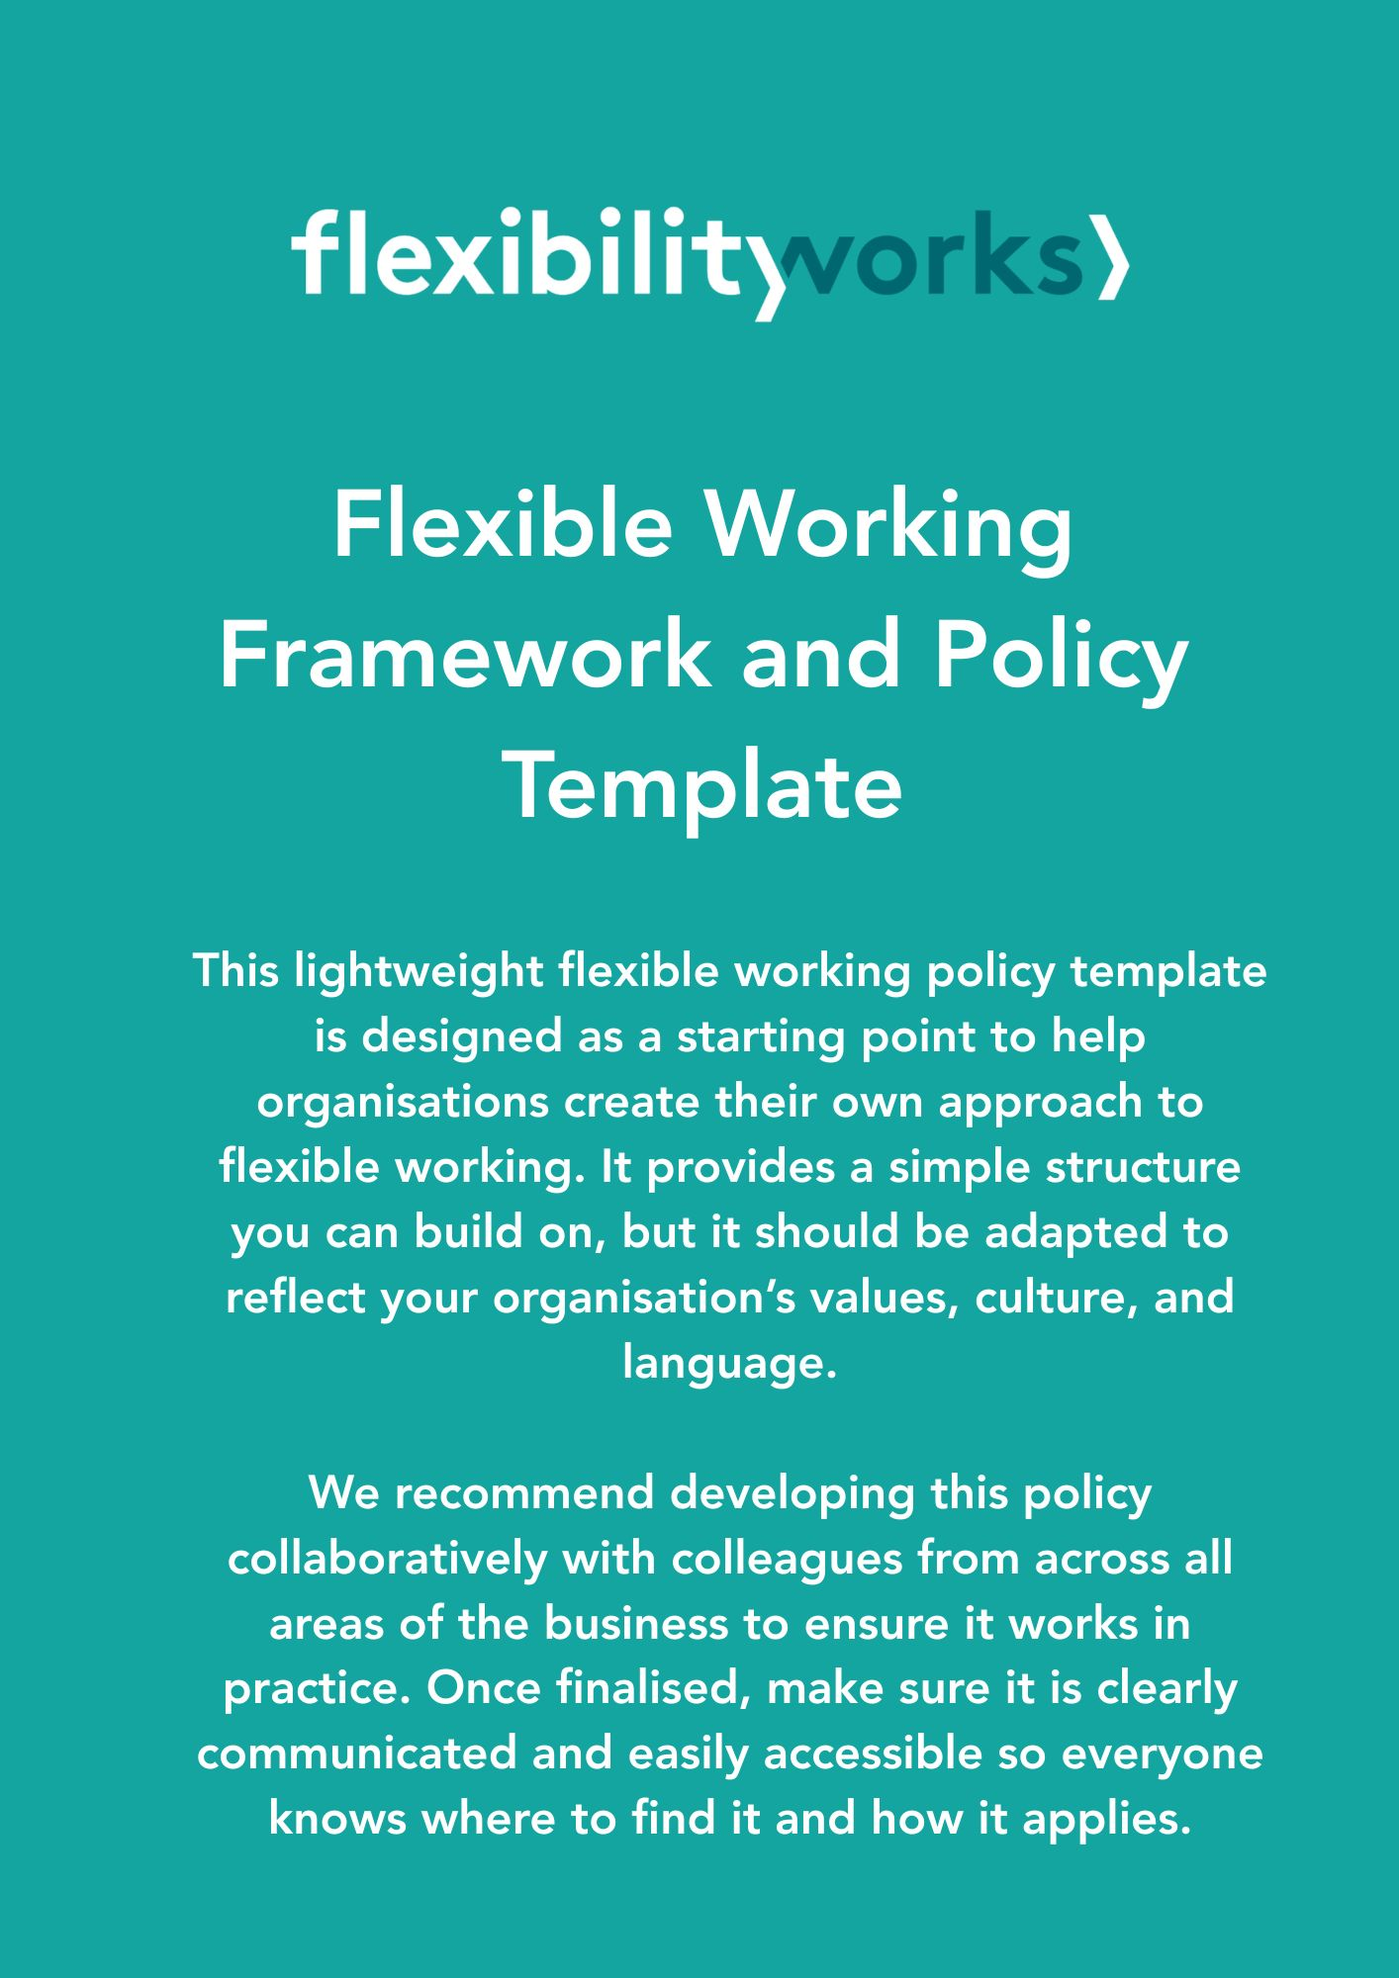

[COMPANY NAME]

Flexible Working Framework and Policy

[DATE]

Purpose and aims of this policy

  - This policy outlines our commitment to flexible working as a way to support wellbeing, productivity, and a healthy work-life balance.

We all need to make sure we can deliver for our customers, in particular customer responsiveness and service quality, so this will be key when considering any request for flexibility.

  - As a small, growing organisation, we want to be transparent about what flexible working may look like at [Company Name], for all current and future staff.
This framework and policy explains how we support flexible working in our team. It covers both informal arrangements, like occasional changes to hours, and formal arrangements, where you make an official request to change your working pattern.

Introduction to our flexible working policy and culture

  - We recognise the competing demands of work and home/family life, pressures in areas such as health and wellbeing, caring responsibilities, financial stability and much more. So it’s important to us that we demonstrate our commitment to flexible working both in practice and through our values and culture.
  - As a growing family run business, we take pride in achieving the best result for our clients; to help us achieve this our company culture is based on trust and open communication. We want our flexible working arrangements to mirror this:
- We want to be open and approachable, and work in a way that is right for you and the business
- We want our ways of working to enable us all to deliver great customer service and get the work done effectively
- We want our ways of working to be open, clear, fair and sustainable for the future as the business grows

  - We want you to enjoy working here and feel supported and safe to be able to discuss and raise issues about what helps you to work effectively.

- Types of Flexible Working
Flexible working can be informal - for example, to occasionally adjust your start or finish times, or to work from home sometimes. It can also be formal, meaning a change to your contract (as explained further in sections 3.2 and 4). Sometimes it might be a mix of both informal and formal, for example working part-time formally, but also informally adjusting your start and finish times now and then.

  - Informal flexible working

We want to be able to support the team to manage your day to day working arrangements without the need to always make a formal flexible working request. At [Company Name], informal flexibility might look like:
- Flexible start and finish times
- Last minute day swaps so you can attend important appointments
- Swapping days of work with a colleague (assuming it meets business need)
- Taking time out of your working day to make or receive important calls about your family or dependants
- Working from home (where the work is appropriate to be carried out remotely)

If there are ever any issues with informal flexible working, in the first instance we would have a conversation to try and resolve this together.

We all need to make sure we can deliver for our customers and “get the work done”, so this will be key when having any discussion about flexibility.

  - Formal flexible working
There are many reasons why you might want or need formal flexible working. Everyone is different, so may need different ways of working. The following are all examples of formal flexible working:

- Part-time working
- A set day(s) working at home
- Job sharing
- Compressing your hours into fewer days
- Location of your role

You may need support using flexible working either on a short term or ad hoc basis or by making a permanent change to your contract of employment. Either way, come and speak to us as soon as possible so we can provide support that will help you both work effectively and enable us to meet business needs.

Making a formal flexible working request
4.1 In addition to having informal flexibility in place as set out in section 3.1, you are entitled to make a statutory request if you are an employee and want to make a change to your contract of employment. You can do this from the first day of your employment and you can make a maximum of two statutory flexible working requests during any 12-month period. A request cannot be made until any previous request has been concluded in full.

All requests must be submitted to us in writing. You can do this by completing the ‘Flexible Working Application Form’ found in Appendix 1, where you are asked to tell us what you would like to change and when you would like it to take effect.

We will then meet with you to discuss the application.

Each request for flexible working will be considered on its own merits based on current business requirement(s) as outlined in Section 4.3. Once a decision has been reached regarding your application, we will let you know the outcome and then write to you to confirm this. A final decision will be provided, including the outcome of any appeal, within two months of receiving the initial request (unless we both agree to extend the timescale).

Where our decision is to agree to your application, the notice will specify the contract variation agreed to and state the date the variation will take effect. This will mean a permanent variation of your contract, unless we agree otherwise. Therefore, once a change has been made, there is no right for you to revert to your previous terms and conditions. Further requests will count towards the maximum amount permitted in any 12-month period.

There may also be occasions whereby we discuss trialling your request for a set period, to allow both you and [company name] the opportunity to assess how your new arrangement is working. We will then meet up towards the end of your trial period to review whether I wish to continue under a permanent arrangement or revert to your original working pattern. Any trial period will be agreed before your flexible working request takes effect and the length of the trial will be outlined in writing.
4.3 Where we can’t agree to your application, we will let you know why and what you can do next. The statutory grounds for rejecting a flexible working request are as follows:
- extra costs that will damage the organisation
- the work cannot be reorganised among other staff
- people cannot be recruited to do the work
- flexible working will affect quality
- flexible working will affect performance
- the organisation will not be able to meet customer demand
- there’s a lack of work to do during the proposed working times
- the organisation is planning changes to the workforce

- Appeal

  - If we cannot agree to your flexible working application for one of the reasons set out in Section 4.3 above, you may appeal the decision within 14 days of you receiving notification of the refusal.
  - The notice of appeal must be submitted in writing to us where you should clearly state the grounds of appeal, i.e. the basis for believing the decision to be unfair.
  - After you have submitted your appeal, we will schedule a meeting with you to discuss the appeal within 14 days of receipt of the appeal notice. You should take all reasonable steps to attend, and you are entitled to be accompanied by a colleague.
  - Following the appeal meeting, we will consider all the information gathered and advise you of their decision within 14 days of the meeting taking place. You will also receive written notification of the decision within this timeframe.
  - Where we uphold the appeal, the notice will specify the contract variation agreed to and state the date from which it will take effect. Where the decision is to dismiss the appeal, the notice will state the grounds for the decision and contain an explanation as to why those grounds apply. The notice will also state that there is no further right of appeal.

Appendix 1: [Company Name] Formal Flexible Working Application Form

This form should be completed in accordance with [Company Name] flexible working policy. Once you have read the policy, please complete this form and submit to me for consideration. I will then aim to meet with you to obtain further detail prior to deciding.

Employee Details
Name:
Job Title:
Team

Details of Request
Please set out the details of the change you are asking for
Ideally, when would you like this change to come into effect?

Please note down any other Flexible Working applications you have made in the past 12 months and the date this was made.

Acknowledgement

Signed:
Date:

